# CMPE 251 Course Project

Project Title: xxx xxx xxx

Group Name: xxx

Students:

1. Name Surname student-id
2. Xxx xxx xxx

## Abstract

A brief and accessible description of the project

## Introduction

Research goal definition

## Methods that were used for data acquisition and processing

##### Data engineering Part

(a) Data retrieval

(b) Data preparation

##### Data science Part

(a) Data exploration

(b) Data modeling

## Results that were obtained

## Conclusion

## Appendix

# Project Code-*Describe your machine learning methods*

Write your codes with a lot of comments.

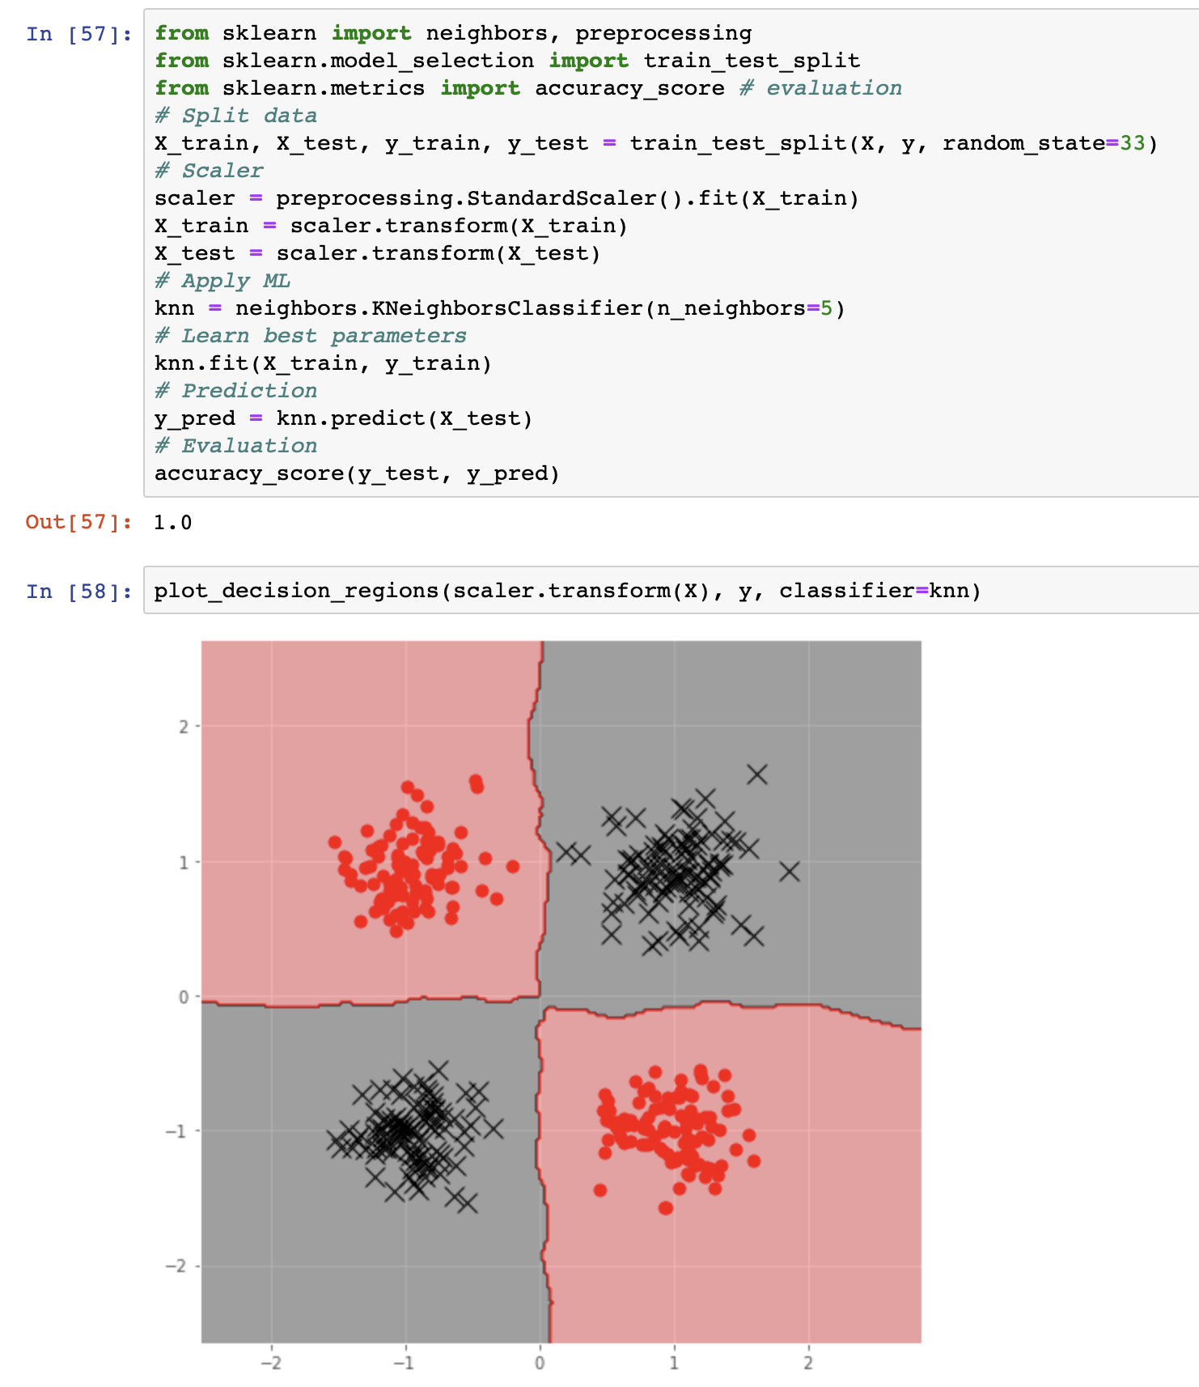

# Project Data *- Describe your data*

**Data Collection** You will get data from eksisozluk with web scraper. Each student will label 500 comments on eksi. 5 label means 5 class.

* 5 Very Positive
* 4 Positive
* 3 Neutral
* 2 Negative
* 1 Very Negative

Each group MUST have different data sources. Different "gundem" topics from Eksisozluk.

# Discussion

* What were the unexpected difficulties in your project?
* How can you improve your results?
* What can be done for future work.